(Approx. 739 words)

Discovering Windows 7 – Part 18
By Neil Stahfest, Vice President, Tacoma Area PC User Group, Washington
August 2011 issue, the Data Line
NCStahfest (at) msn.com
www.tapcug.org

A reader emailed me to ask if I had any suggestions that would darken the text on
his computer’s display and make it more legible. It was an interesting question and
it occurred to me that this would be a good topic for “Discovering Windows 7.” In
researching this topic I discovered Windows 7 provides three primary ways to improve the readability of your display.

We’ll start with screen resolution. For the sharpest image, it’s important for your
video settings to match your screen. Click on the Windows Start button and type
“screen resolution.” In the window that appears select “Adjust screen resolution.”

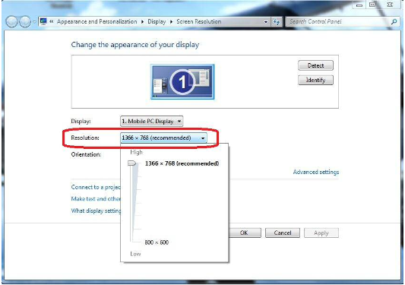

When you click on the button next to “Resolution” (marked in red) you’ll see a slider that controls the range of screen resolutions available on your monitor. With LCD displays, the maximum number represents the number of horizontal and vertical pixels in your display. For the sharpest image, always use the maximum number of pixels; other settings may look blurry. After you’ve made your choice, click “OK.”

Next, let’s look at color calibration. Color calibration adjusts the colors by changing different color settings so they are accurately shown on your screen. Windows 7 includes color calibration software with a “wizard” that makes it this easy to do. The changes that you can make depend upon your monitor and its capabilities so there may be some settings that you can’t change. The “wizard” will let you skip steps that don’t apply to your computer.

To start, click on the Windows Start button and type “color management” in the search box (marked in orange).

Windows will display a list of programs that include “color management.” Select “Color Management” as shown (marked in red).

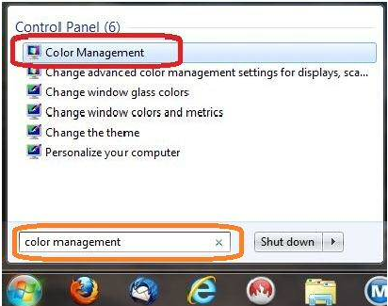

The “Color Management” window will open. Select the “Advanced” tab (marked in orange). There is a lot of information, with many settings on this page but we are just interested in the button labeled “Calibrate Display” (marked in red).

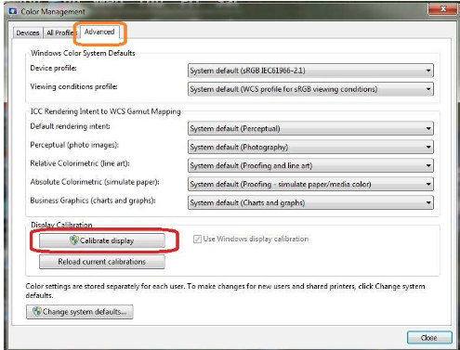

The welcome window for calibrating color opens. Click on the “Next” button in the lower right corner of the screen to start.

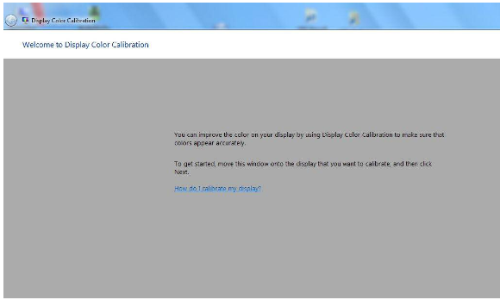

This will lead you through a series of screens. As you go through them you will learn how to adjust gamma, brightness, contrast and color balance settings. Brightness and contrast settings may not be available on all displays.

Laptops PCs, for example, often have brightness controls available among the function keys but no controls for contrast. If you have an LCD display, when you reach the last screen in the color calibration group, make sure that the box to “Start Clear Type Tuner” is checked (marked in red). Finally, to save your new color calibration, select the “Current calibration” button (marked in yellow) or click the “previous calibration” button to revert to the previous one.

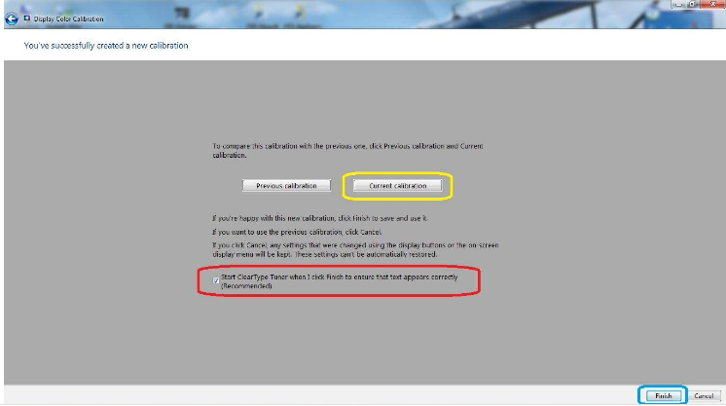

The final step is to click on the “Finish” button to end color calibration.

If you clicked on the box next to “Start Clear Type Tuner” (see above) you will see the screen shown below. This utility, as explained on the screen, improves the readability of text on LCD flat screen monitors. It doesn’t do anything for old style CRT monitors.

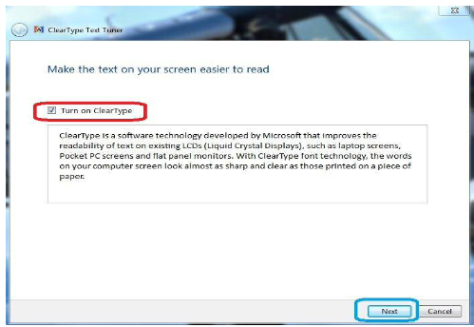

If the box next to “Turn on Clear Type” is checked (marked in red) when you click on the “Next” button (circled in blue), you will be lead through a series of seven screens in which you select the “best looking” type (sort of like an eye test). This should give you the most legible type for your screen.

The final process that we’ll look at allows you to change the size of the letters on your screen. You begin by clicking on the Windows “Start” button and typing “display” in the Windows search box. In the window that appears, select “Set custom text size (DPI)” (marked in red).

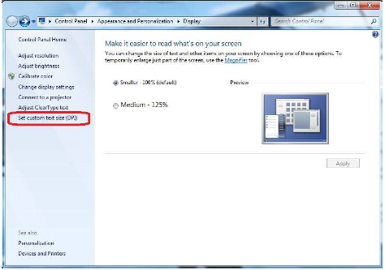

When you click on it you will see the “Custom DPI Setting” window (see below). Experiment with various sizes to improve letter readability.

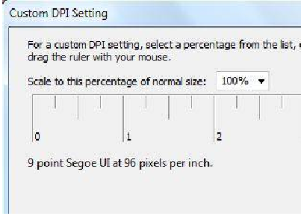

The above procedures are particularly helpful if you install a new display or video card on your computer. Even if you don’t, you may discover that they will be an improvement on the settings that were on your computer when you bought it. In my case I noticed a subtile, but significant, improvement in the display on my desktop PC.

